Task 2:

Jira Fundamentals - 3 hour(s)
- Understanding Jira Projects and Project Types: Team-Managed vs Company-Managed.
- Jira Issue Types Explained: Task, Story, Bug, Epic, and Subtask.
- Creating and Managing Issues in Jira.
- Issue Hierarchy and Linking Issues: Epics, Stories, and Subtasks.
- Working with Kanban and Scrum Boards in Jira.
- Backlog, Board, and Detail Views.

Understanding Jira Projects and Project Types: Team-Managed vs Company-Managed ::
In jira Software, a project is highest level container. It contains issues, boards,workflows, Team members, settings. It can be a product, team, or department. It is a workspace where all related work lives.
- Team Managed Projects :
- Controlled by team itself.
- No jira admin needed.
- Separate workflos per project.
- Simple & Flexible.
- Used when small teams and startups.
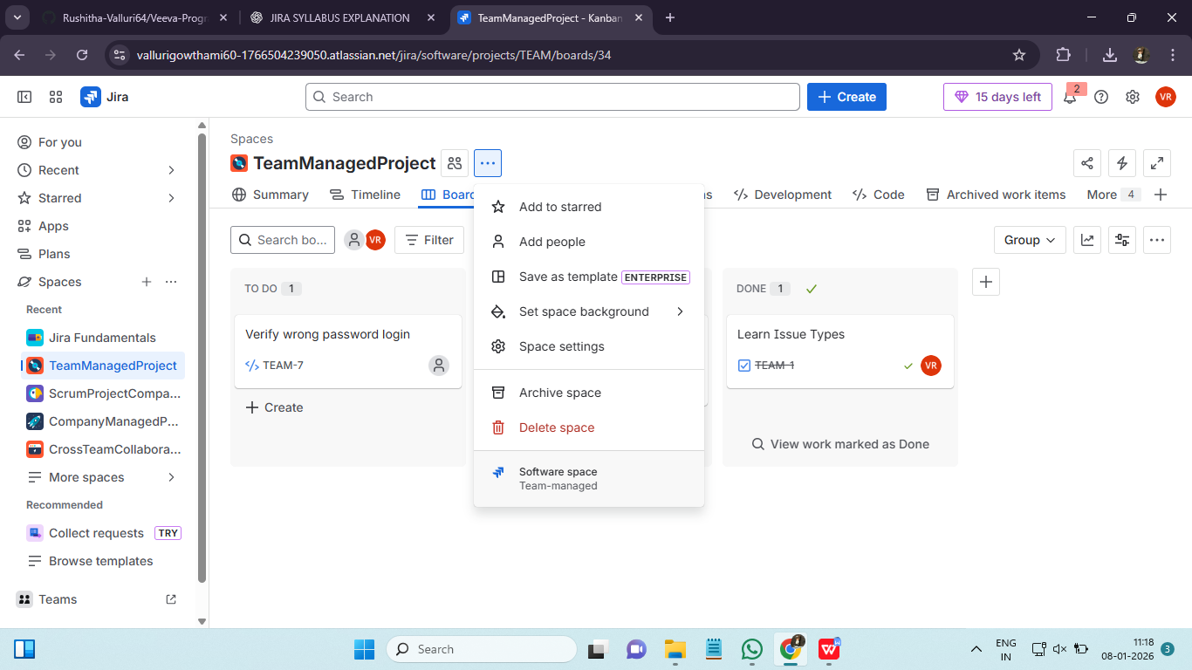
- Company Managed Projects :
- Controlled by organization level admins.
- Shared workflows and issue types.
- Strict governance.
- Used when large enterprises.
- Many teams are working together.

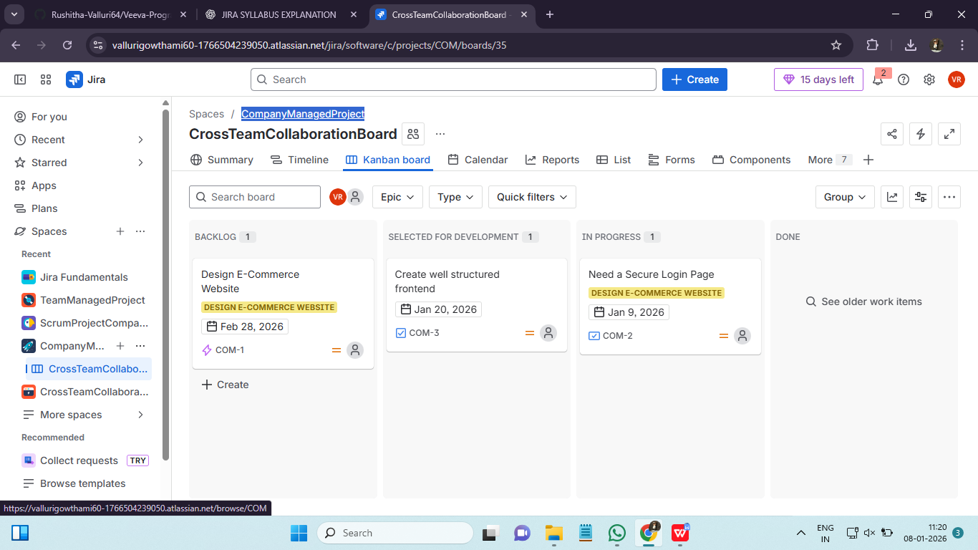

Jira Issue Types Explained: Task, Story, Bug, Epic, and Subtask ::
Any work item that needs to be tracked is an issue in a jira project.
Issue types :
- Epic : Large feature / Long term goal / multiple tasks
- Story : User requirement
- Task : Technical or general work not user focused
- Bug : Defect in existing feature or task
- Subtask : Smallest unit or part of story or task
Issue types helps in sprint planning, reports generation, QA, dev and PM roles.
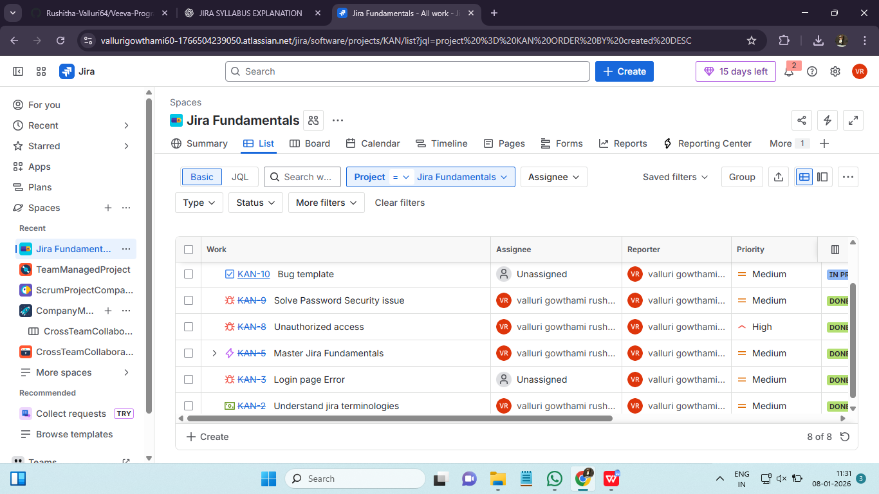

Creating and Managing Issues in Jira.
Issues can be created from the Create button, backlog, or board.
Creating an issue deals with
- Defining work
- Giving it a name
- Saving it
Managing issues deals with
- Assigning work
- Setting prority
- Updating status
- Communicating via comments

Issue Hierarchy and Linking Issues: Epics, Stories, and Subtasks ::
In jira, hierarchy is how jira organises big work into smaller, manageble pieces because big goals cant be completed and tracked in one step.
Epic - Story/task - Subtask
Levels in Hierarchy :
- Epic : A large feature or objective. It may complete in a span of weeks or months. Mostly used by project managers , product managers and team leads. We can track overall progress, check status of each task and report it to stakeholders.
- Story : A requirement from user’s perspective. It describes what the users want. Mostly product owners, developers uses it.
- Task : A piece of work not written as user story. It may be a technical or operational.
- Subtask : Smallest unit of work. Always belongs to story or task and used for daily execution. It cannot exists alone.
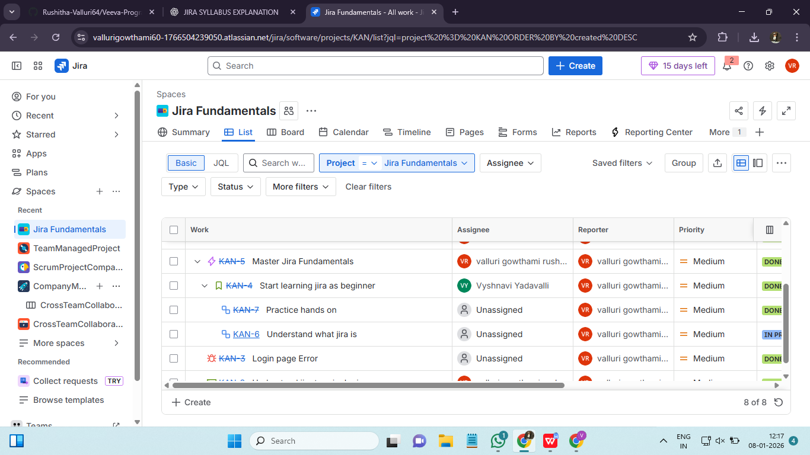

Issue Linking : It connects issues that are related or dependent even across projects.
Common Link types :
- Blocks : One issue must finish first.
- Is blocked by : Waiting for another
- Relates to : Related but no dependency
- Duplicates : Same issue repeated twice
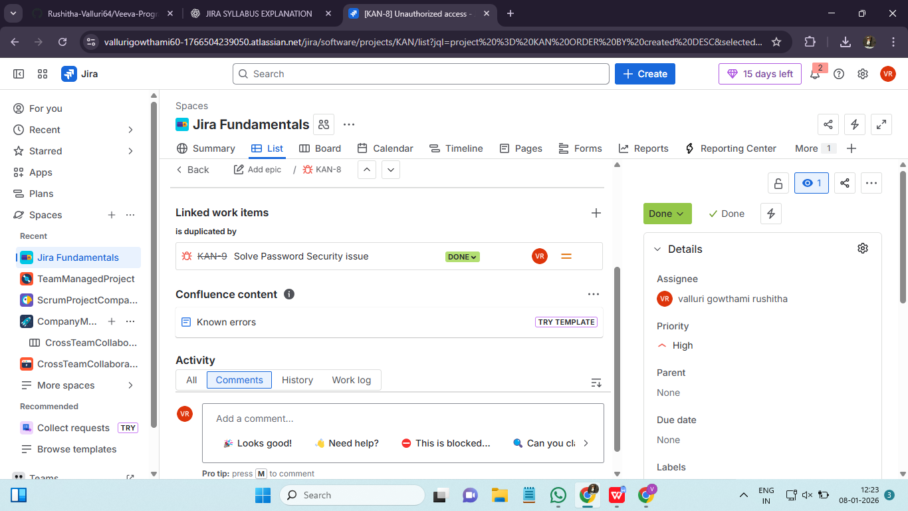

Working with Kanban and Scrum Boards in Jira ::
A board is a visual screen that shows issues, their statuses and progress. Jira supports mainly 2 types of boards :
- Kanban board
- Scrum board
- Kanban Board :
Visulaises work & move it continously untill completion. There are no sprints and deadlines. Support teams, Maintenance, Devops teams uses kanban boards.
Structure of kanban board : To Do -> In progress -> Done
- Scrum Board :
Scrum is time boxed development. It cotains fixed length cycles called sprints usually of 1-2 weeks. It will exists only for a sprint. Product development, feature based, agile software teams use scrum board. Scrum uses kanban style inside each sprint.
Structure of scrum board : Backlog -> Active Sprint -> Done

- Kanban board :
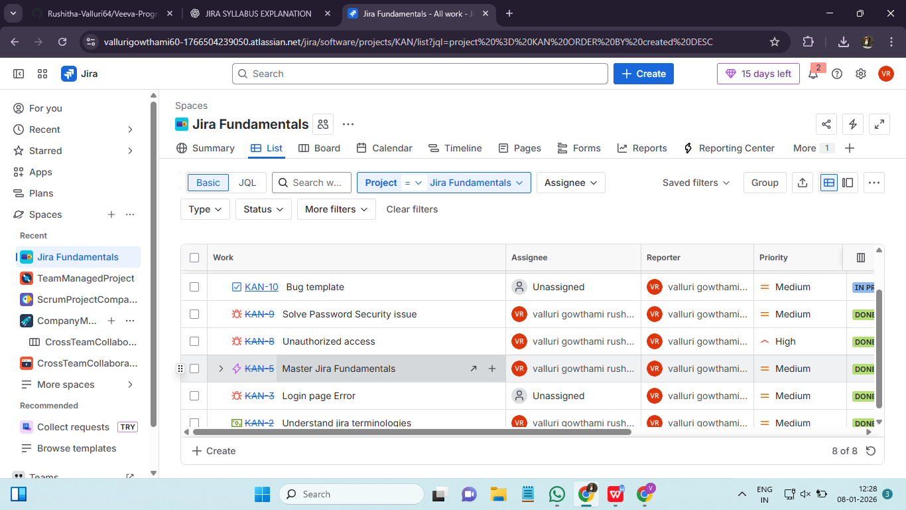
- Scrum board :
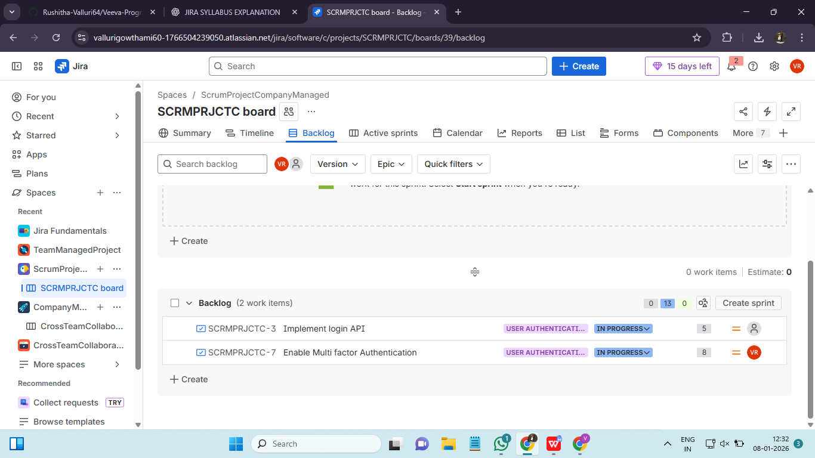

Backlog, Board, and Detail Views ::
A view in jira is simply a way to look at the same issues from different perspectives. Jira provides 3 core views.
- Backlog view : Planning
- Board view : Daily work tracking
- Detail view : Full issue information
- Backlog view : Backlog is a priortized list of future work that has not started yet. All the work is planned to do later. It contains stories, tasks, bugs and epics. This view helps to decide to what to work on next. In this view priority or order matters.
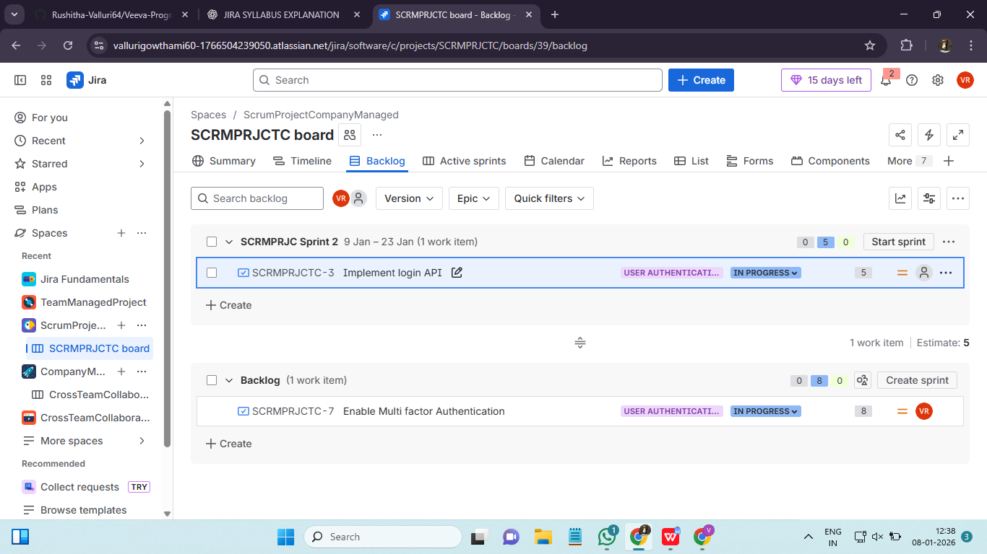
- Board view : Board shows work that is currently happening. It is a status based. Developers, QA teams use board views for daily standups. Boards can be grouped by assignee, priority, status etc…
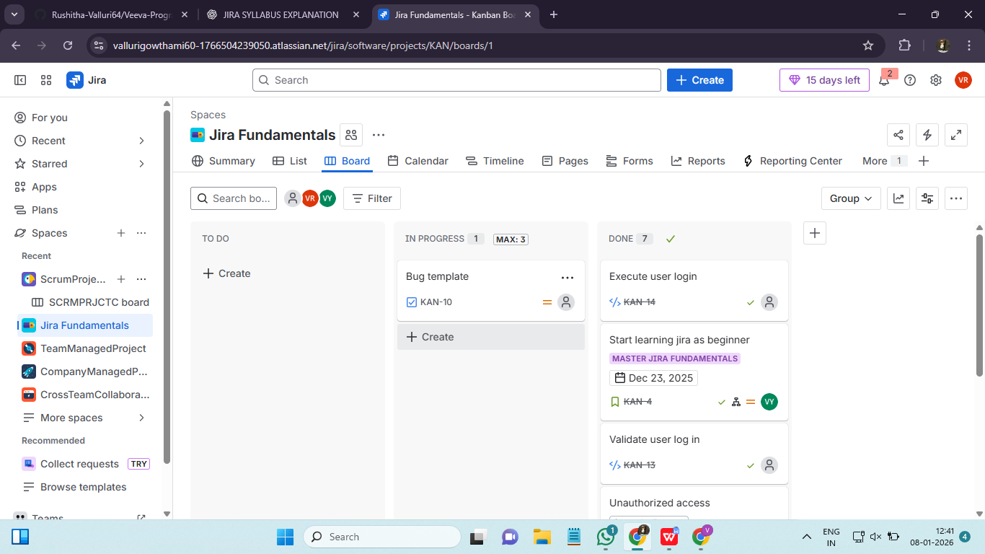
- Detail view : Detail view shows everything about a single issue. It contains summary, description, assignee, priority, comments etc…By using this issue developers discuss and update work.
